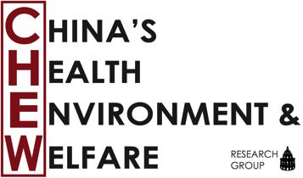
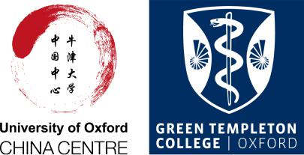

CHEW Conference 2017

University of Oxford
26 May, 2017
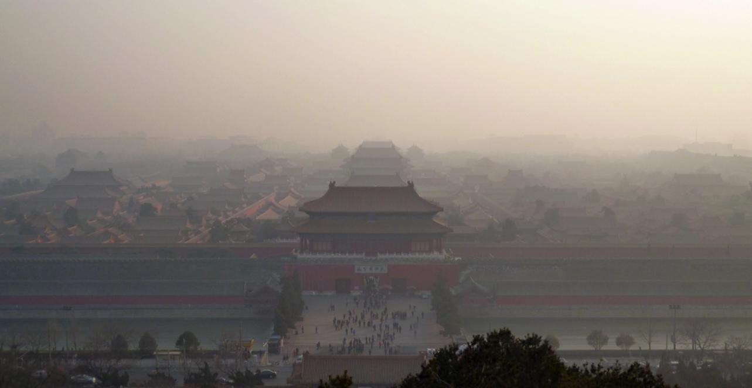

Contesting Modernisation:

The Future of Health, Environment,

and Welfare in China

Contents

Conference Committee | 2
About CHEW | 2
Conference Venues | 3
Keynote Speech | 4
Conference Schedule | 5
How to get to Oxford | 8
Accommodation | 8
Contacts, Maps and General Info | 9

1

Conference Committee

Dr. Loretta Ieng Tak Lou
Irina Fedorenko
Rowan Alcock
Hosanna Wang

About CHEW

China’s Health, Environment, and Welfare (CHEW) is an interdisciplinary research group at the University of Oxford. CHEW is a forum for graduate students, early career researchers, and established academics from across the social sciences and humanities, as well as policy and civil society actors working on contemporary China.

CHEW was founded in 2013 and had its inaugural conference in Green Templeton College in 2014. We host regular seminars and lectures and share information about events, conferences and new research findings through various online platforms. Over the past four years CHEW has hosted talks by: Dr. Michael Hathaway (Anthropology, Simon Fraser University), Dr Stuart Basten (Department of Social Policy and Intervention), Fergus Green (Grantham Institute on Climate Change and the Environment, LSE), Dr Jenny Chan (Applied Social Science, Poly U Hong Kong), Mia MacDonald (Brighter Green, New York), Isabel Hilton (chinadialogue.net, London), Prof Peter Ho (Delft University of Technology), Liang Chen (University of Westminster), Dr Mao Da (Nature University NGO), Prof Lina Song (University of Nottingham), Dr Paul Jobin (University of Paris Diderot), Prof. Robert Weller (Anthropology, Boston University), Prof. Prasenjit Duara (East Asian Studies, Duke University), and many others.

The current CHEW committee would like to thank student volunteers for their help and support of previous CHEW conferences: Caleb Pomeroy, Saher Hasnain, Peter Chan, Matthias Qian, Guanli Zhang, Huw Pohlner, Clement Sehier, and Carlo Inverardi Ferri. We also thank the China Centre and the University staff for their support over the years. In particular, we acknowledge the help of Prof Rana Mitter, Dr Anna Lora- Waiwright, Dr Troy Sternberg, Clare Ochard, Rosanna Gosi, Chris Sauer, April Lopez, and Sue Drakes for their dedicated support.

The CHEW Conference 2017 has been generously funded by the University of Oxford China Centre and Green Templeton College. We also thank the ESRC and DTC research fund for their support in previous years.

Loretta, Irina, Rowan, and Hosanna

2

Conference Venues

University of Oxford China Centre

The University of Oxford China Centre is a new hub for academic activities related to China, located on the premises of St Hugh's College.

Dickson Poon Building, Canterbury Road, Oxford OX2 6LU

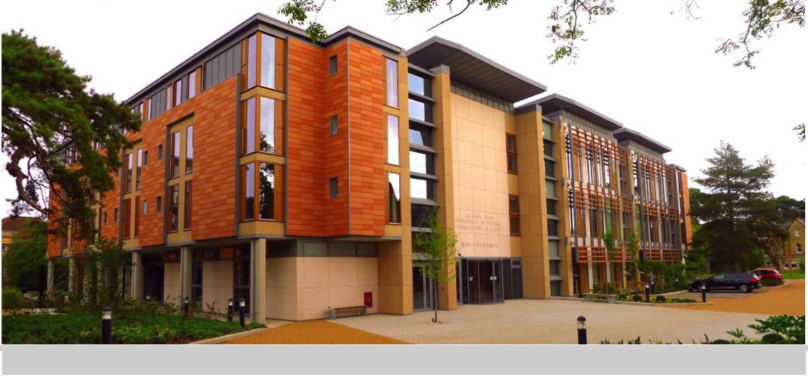

3

Keynote Speech

Professor Micha Muscolino, University of Oxford
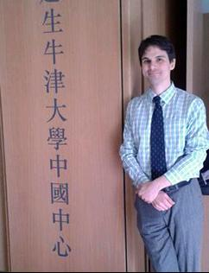
Micha Muscolino is Professor of Chinese History at Oxford University and Jessica Rawson Fellow in Modern Asian History. His research concerns cementing the complex interplay between recent environmental developments and patterns in deeper roots of China’s history.

Micha's publications include: The Ecology of War in China: Henan Province, the Yellow River, and Beyond, 1938-1950 (Cambridge University Press, 2014), which explores the interplay between war and the environment during the conflict between China and Japan and Fishing Wars and Environmental Change in Late Imperial and Modern China (Harvard University Asia Center, 2009), which looked at interactions between society and environment in China’s most important marine fishery, analyzing the local, regional, and transnational forces that shaped struggles for the control of these common-pool natural resources and transformed the marine ecosystem.

His research has been supported by fellowships and grants from Fulbright (IIE), the Center for Chinese Studies at the National Central Library in Taiwan, and the Chiang Ching-kuo Foundation.

4

Conference Schedule

Venue: Lecture Theatre 1 – China Centre

10:30 - 10:45 Welcome speech

10:45 - 11:45 Keynote speech
Micah S. Muscolino
Professor of Modern Chinese History
University of Oxford

11:45 - 12:30 Lunch break

Environmental Sustainability and Social Justice

12:30 Dr Jennifer Holdaway, University of Oxford
Balancing Environmental and Social Justice:
Implications of China’s Stronger Environmental Protection Policies for Rural-Urban Inequality.

12:45 Alexandra Foote, London School of Economics
Community Based Ecotourism in the Tibetan Plateau

13:00 Chang Liu, Jilin University Institute for Chinese Studies
Picking up the Fashionable Items from Transnational Waste: On Chinese Women's Striving for Post-Revolutionary Chinese Femininity

13:15-13:30 Question time, chaired by

Environment and Modernity in Transitional China

13:30 Dr. Jan Erik Christensen, Independent Scholar
Confucian Philosophy, Education, and Ecological
Sustainability.

5

13:45 Dr. Chaohua Wang, Independent Scholar
Societal Empowerment for a Better Future in China.

14:00 Coroline Goron, University of Warwick
‘Ecological Civilization’ and the Continuation of Modernization Politics in China.

14:15-14:30 Question time, chaired by

Coffee and Tea Break (14:30-15:00)

Activism and Grassroots Movements

15:00 Dr Nicholas Loubere, Lund University
Microcredit, Modernity and Marginalisation in Rural China.

15:15 Suzanne Barber, Indiana University
Animal rights activism

15:30 Li Zipeng, University of Edinburgh
Would the ‘Online Public Voice’ be Considered by the
Chinese Government During the Environmental Crisis?

15:30-15:45 Question time, chaired by Irina Fedorenko

Animals and Chinese environments

15:45 Dr. Kin Wing Chan, University of Cardiff
The Preformative Eco-Friendly Farmers: Governmentality
and Regulation of Animal Waste Practices in Hong Kong
(1973-1997).

6

16:00 Dr Alisha Gao, Goethe University
Solving the Negative Externalities of Factory Farming in China Intensive Livestock Production.

16:15 Dr Thomas White, University of Cambridge
Patriotic camels and the Political Ecology of China’s Borderlands.

16:30-16:45 Question time, chaired by Dr. Loretta Lou

Coffee and Tea Break (16:45-17:15)

17:15-18:15 Roundtable Discussion

18:15-18:45 Wine reception

19:00 Conference Dinner at Zheng Restaurant

7

How to get to Oxford

The conference venues – the Oxford China Centre and Green Templeton College – are located in the centre of Oxford with most colleges and University departments within walking distances.

By Coach and Train

Oxford can be easily reached by bus from central London, by train from the station of London Paddington, as well as directly from other cities or airports in the United Kingdom.

24 hours coaches to/from London |  |  |  | http://www.oxfordbus.co.uk/
Coaches to/from London Airports |  |  |  | http://airline.oxfordbus.co.uk/
National Rail Enquires |  |  |  | http://www.nationalrail.co.uk/
Taxis
Royal Taxi | +44 | (0) | 1865 777333
A1 | +44 | (0) | 1865 248 000
ABC | +44 | (0) | 1865 770077
 | +44 | (0) | 1865 775577
Radio Taxis | +44 | (0) | 1865 242424
 | +44 | (0) | 1865 249743

Accommodation

University Rooms Oxford System: http://www.universityrooms.com/
Department of Continuing Education: https://www.conted.ox.ac.uk/facilities/accommodation/
University Club: http://www.club.ox.ac.uk/accommodation

The Cotswold Lodge Hotel: http://www.cotswoldlodgehotel.co.uk/

8

Contacts, Maps and General Info

University of Oxford China Centre

Dickson Poon Building
Canterbury Road

Oxford OX2 6LU

Conference email: chewoxford@gmail.com

Emergency Medical Assistance - At any time dial 999

Weather: Weather in Oxford could still be a bit chilly in May. Don’t forget to bring a jumper.

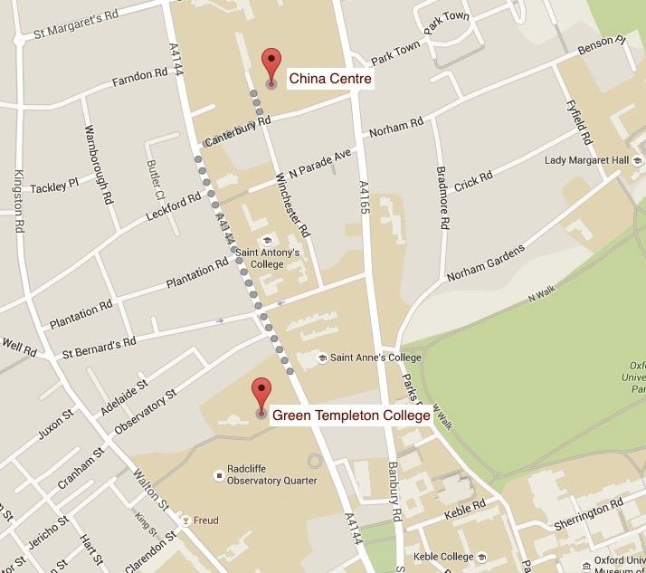

9
Abstracts

Community Based Ecotourism in the Tibetan Plateau
Alexandra Foote, London School of Economics

With its endless green fields and pure blue lakes, there’s no question why the Tibetan Plateau has become a hotspot destination for tourists and ecotourists from around the world. Previous reports have discussed the detrimental effects mass tourism has on the Tibetan Plateau’s environment; however, no studies or news outlets have covered ecotourism on the Tibetan Plateau in the context of community-led organizations. Environmental news covering Tibet tends to linger on the drastic changes occurring—melting ice caps, desertification, species nearing extinction—without considering possible solutions sprouted from local levels.

In my 2016 Master’s dissertation, I asked how Tibetan-owned ecotourism organizations contribute to environmental conservation and local economic development on the plateau. My research analyzed Community Based Ecotourism, an emerging kind of tourism focused on locally-led initiatives promoting environmental protection, local economic development, and cultural preservation, in a new, understudied area. I consider the context of China’s swelling tourism industry, Tibet’s environmental fragility and poverty, and underlying political tension in the region. Due to existing literature on community-based ecotourism, the hypothesis was that Tibetan-led ecotourism initiatives would focus on conserving the environment and improving local economic development.

The findings, based on 20 interviews with Tibetan-led ecotourism leaders and local residents, participant observation in WeChat forums, and analysis of data from Chinese Statistical Yearbooks, show that Tibetan-led ecotourism initiatives prioritize cultural preservation, which includes environmental protection, and local economic development to improve education, employment, and growth of local business. However, these organizations’ influence on the ecotourism industry is limited due to reliance on Western tourists and restrictions on movement set by the Chinese government. As the ecotourism industry becomes a larger part of the plateau economy and grows with the expanding affluent middle class, it will be important to focus on solutions benefitting both the environment and surrounding community.
Confucian Philosophy, Education, and Ecological Sustainability
Jan Erik Christensen, Independent Scholar

This paper addresses the need for an awareness of our relatedness with the rest of the ecosystem. I argue that Confucian thought facilitates a vision of sustainability and a corrective to the crisis of mind that has separated nature from humanity, informing ecological education on seven levels: 1. Stressing the continuity between humans acting from the ‘humane heart/mind’ (renxin 仁心) and nature, thus we are in an ethical relationship with the rest of the ecosystem (‘all things,’ wanwu 萬物). 2. Taking care of the fundamental needs of the people is a premise for ecological sustainability. 3. Rejecting the view that nature has only instrumental value. 4. Rejecting the dualistic either/or thinking (i.e. anthropocentric/ecocentric, humans/nature) that has dominated the discussion of environmental issues in the West. 5. Rejecting seeking ‘personal benefits’ (li 利) that are not ‘righteous’ (yi 義). 6. Seeing ‘unselfish’ (gong 公) behavior as a premise for becoming a better citizen. 7. Increasing the awareness of how external forces that propagate ecological destruction impede our potential to act from the ‘humane heart/mind.’

Patriotic camels and the political ecology of China’s borderlands
Thomas White University of Cambridge

This paper discusses representations of animals in contemporary China, and explores the relation of these representations to the political ecology of China’s borderlands, focussing on the desert region of Alasha, Inner Mongolia. Recent reports in the Chinese media have highlighted the historical role of domestic Bactrian camels in securing the vast expanses of Inner Asia for the Chinese state. I argue that these stories of ‘patriotic camels’ constitute a discursive resource for ethnic Mongol intellectuals who oppose the government’s radical reforms to animal husbandry in the region. These policies - involving strict stocking limits, enclosure and the relocation of pastoralists - have been formulated in response to the severe desertification of the grasslands, which has been blamed on overgrazing. I go on to show how these media representations of the patriotic Bactrian camel have in turn been influenced by alternative understandings of grassland ecology promoted by these Mongol intellectuals, which suggest that the camel is in fact vital to the health of the grasslands. I thus argue that the Bactrian camel plays an important mediating role in the political ecology of this region, at once a vehicle of Chinese state territorialisation, while also providing Mongols with a way of defending their traditions of extensive animal husbandry.

Societal Empowerment for a Better Future in China
Chaohua Wang, Independent Scholar

There is no question that China’s crisis today in health(care), environmental, and social welfare comes largely from the country’s unceasing pursuit of modernisation on multiple fronts. However, there is indeed question as to what is the opposite of modernization, which might be mobilized, or utilized, in a meaningful contest against modernization. A prevalent view among Chinese intellectuals in recent decades, represented prominently by Wang Hui’s works since the late 1990s, has been that imported modernity from the West since the Opium Wars in the mid 19th century, manifested in particular in a kind of scientism during the May Fourth years, has compelled China into a continuing effort of modernisation, ignoring valuable resources that had accumulated in the Chinese civilization over centuries and could offer rich possibilities for the country to explore alternative paths towards a better future. In this view, China’s socialist experiment under Mao was not much different from capitalist modernization (Wang Hui, The Rise of Modern Chinese Thought, 2004, in Chinese).

In contrast to the above-mentioned approach, this author believes that the fundamental problem in China’s modernisation process today is its developmentalist nature, as well as its strongest backing force in the country’s authoritarian political system. Specifically, the official version of “socialism with Chinese characteristics” is overwhelmingly centralized and State-driven. Social spaces for public debate and discussion have been almost completely squeezed out. With little participatory politics, bottom-up social vision is strangled to a slow death, creating a social environment that is the most friendly to neoliberal developmentalism and the direst to social empowerment in combating water, land and air pollution, as well as in implementing better social welfare programs for the neediest.

Would the “online public voice” be considered by the Chinese government during the environmental crisis?
Li Zipeng, University of Edinburgh

The past research in the area of online public expression and Chinese governance has largely concentrated on censorship, propaganda and control. Under media digitalization trend and policy making decentralization trend in China, it may be worthwhile to reconsider the conventional zero-sum game assumption of the media and politics during environmental crisis. Online public opinion has already shown its political potential through Internet forums and blogs, which attracted scholars’ attention in perspectives of social fairness and environment. This paper raises the hypothesis of the environmental policy impact from online news discussions with a focus of the case Tianjin explosion. The reason to choose this case is that it has attracted many environment-related online discussions and the government quickly responded by holding 14 press conferences addressing relevant concerns. The theoretical framework of this paper includes agenda setting, digital divide and policy entrepreneur. We ask: is the current Chinese government system effective and efficient enough for public opinion to intervene into policy making during environmental crisis? Is there evidence to show that the online news discussion can influence environmental policy making in China during the Tianjin Explosion Case? If so, whose voice online matters more? Why? The discussion of the potential lack of marginalized group’s voice will be developed based on the digital divide theory. The policy entrepreneur theory helps to explain the possibility of policy intervention from the public opinion. Through the assistance of Nvivo, we design content and discourse analysis to explore the theme correlation and the sentiment similarity between the online news discussion and relevant public policies. The study may provide some implications for the potential impact of the online public opinion on policy making in other environment related cases in China.

Suzanne Barber Dual, Indiana University

Recently, the Chinese government has begun to increase its crackdown on NGOs and social activism more broadly, raiding offices and arresting prominent activists. Many activist organizations that deal directly with human rights have either been shut-down or been forced underground. Despite these harsh measures, Chinese animal rights organizations have been allowed to continue to function, and in some cases are even directly supported and encouraged by the local government. An increasing number of animal rights advocates are becoming active in other social movements, especially environmentalism, LGBTQ activism, and workers’ rights. Animal rights activists, primarily middle-class women between 18-35 years old, do not view rights as separate from these censured humanitarian causes, but rather that it appears to serve as a vehicle through which volunteers can advance a variety of human rights initiatives. This paper will investigate the degree to which activists see animal welfare as having a potential to become a question of citizenship and animal rights movements to become a way for individuals to position themselves as deserving subjects within a society who recognize their basic rights. To do so this paper will answer two primary questions: 1) How have animal rights organizations continued to operate during a time of harsh governmental crackdowns on other social organizations? And (2) what connections exist between animal rights organizations and other forms of activism?

Protecting the Weak - Entangled processes of framing, mobilization and institutionalization in East Asia
Alisha Gao, Goethe University

Solving the Negative Externalities of Factory Farming in China Intensive livestock production, commonly known as factory farming, has becoming the fastest growing sector in Chinese agriculture since its adoption in the 1980s. The Chinese government has been actively promoting the methods and practices of factory farming to enhance efficiency and productivity. Factory farming’s role in agricultural modernization has met rising consumption demands for access to cheap meat. However, the appropriation of industrial practices to livestock husbandry in China has created risks: environmental issues, food safety and adverse animal welfare. This paper will analyze the political response to these growing externalities of meat production modernization in light of reflexive modernization, the theory of the modernization of industrial society. Reflexive modernization finds that the consequences of modernization lie not in the deficiencies of modernization, but in modernization’s successes. The negative externalities of modernization are becoming more apparent today, case-in-point by the growing awareness of factory farming’s effect on the environment, public wellbeing and animals. However, the consequences of pursuing this model can either be blamed on traditional practices, in which the role of factory farms are downplayed and concealed, or an awareness of risky industrial practices could promote solutions of secondary industrialization or an attempt at removal of the primary causes. This paper seeks to provide a preliminary exploration of the legitimizations by the Chinese government for continuing to pursue intensification in their attempts to control or solve visible negative externalities. The role of science and technology will be of key importance in this preliminary analysis of the solutions for the negative externalities of modern meat production in China.

Picking up the Fashionable Items from Transnational Waste:
On Chinese Women's Striving for Post-Revolutionary Chinese Femininity
Chang Liu, Jilin University Institute for Chinese Studies

In contrast to the common practice of breast binding and wearing uni-sex uniforms during China's revolutionary era, fashion and new images of female body were introduced to Chinese women after China's implementation of reform and opening up policy in the late 1970s. Due to the underdeveloped market economy and lack of fashionable clothes, a new feminine appearance was desirable yet difficult to achieve for Chinese women. Against this background, clothes dumped by foreign countries and exported to China as transnational waste became relevant for Chinese women's negotiation of post-revolutionary Chinese femininity. Based on qualitative research and studies of oral evidences collected through semi-structured interviews with selected informants, this paper examines the consumption of dumped foreign clothes in Changchun China between the late 1980s and early 1990s. It begins by considering consuming and wearing dumped foreign clothes as a way to release repressed femle body and to become fashionable. It then moves on to analyze women's awareness of dumped foreign clothes as potentially contaminated and accompanied with health risk, and how a female bond emerged from their concern of health. Existing scholarship argues that the construction of China's post-revolutionary femininity is largely done by men and accompanied by the return of male supremacy. However, this paper suggests that Chinese women's consciously consuming and wearing dumped foreign clothes – on the cost of bearing potential health risk – enable them to participate in the construction of post-revolutionary Chinese femininity and develop a westernised hybrid Chinese femininity, which counter against the male led revival of traditional Chinese femininity.

Ecological civilization” and the continuation of modernization politics in China
Coraline Goron, University of Warwick

What is the meaning of ecological civilization? Introduced by President Hu Jintao in 2007, it has been hailed as a conceptual innovation capable of catalysing political and social forces to push for an ecological transition in China. The paper discusses the different environmental discourses embodied in the concept of ecological civilization, to show that the environmental field in China, as elsewhere, has been re-invested with the unsettled politics of modernization (Zizek, 1991). Firstly, ecological civilization encompasses both western theories of “ecological modernization” (Mol & Spaargaren, 2000) and their critiques (Huan, 2008, 2015). Those who portray it as the next step in the development of human civilization (e.g. Zhou, 2009) adopt the same teleological posture as ecological modernists. However, ecological civilization may on the contrary denounce the techno-fix promises of ecological modernization and carry the ambition to forge an alternative development paradigm for China’s ecological transition (Niu 2010). The second issue concerns where these alternatives take roots and in which political direction they develop. Some propositions grounded in eco-socialism (Pan, 2006) and re-interpretations of Chinese traditional culture (Tu Weiming 2001), can support the embedding of environmentalism in China against its political construction as a “western” concern. But they can also end up constraining China’s environmental movement by comforting orientalist and nationalist discourses (Gaffric & Heurtbise 2013) and by putting the responsibility back in the controlling hands of the CPC (Hilton 2013). The paper argues that since the CPC has claimed ecological civilization as one of its core missions in the pursuit of “socialism with Chinese characteristics” (Huang 2015), the institutional reforms it has introduced to “green” its exercise of power also risk capturing the environment into the very modern logic of authoritarian state building.

Balancing Environmental and Social Justice: implications of China’s stronger environmental protection policies for rural-urban inequality
Jennifer Holdaway, University of Oxford

With mounting concern over the impacts of pollution from industry and intensified agriculture on ecosystems and human health in China, in recent years a considerable number of researchers have focused their attention on interactions between environment, health and development in rural areas. This paper uses a number of case studies supported by the Forum on Health, Environment and Development (FORHEAD) to explore the implications of recent, stronger environmental protection policies for rural development and rural-urban inequality. It considers the way in which rural poverty alleviation and development policies have interacted with concerns over environment and health over time and what we know so far about the possible impact of current policies. While raising more questions than can be answered at present, it suggests that while stronger action to prevent and control air, water and soil pollution is certainly desirable, the cost of these policies appears to be falling disproportionately on rural people. This calls for more integrated analysis of environmental and social justice to inform policy across multiple streams.

The Preformative Eco-Friendly Farmers: Governmentality and regulation of animal waste practices in Hong Kong (1973-1997)
Kin Wing (Ray) Chan, University of Cardiff

This paper examines the governmentality of the colonial government of Hong Kong between 1970s and 1990s, focusing on how it implemented Livestock Waste Control Scheme (1973-1997), produced normative waste treatment knowledge, and the spatial control of farming practices as technologies to ameliorate the water pollution problem and produced the subjectivity of eco-friendly farmers. This paper comprises two major objectives: to (1) elucidate how the production of knowledge and spatial tactics are employed to transform polluted farmers into “eco-friendly”; and (2) examines how farmers negotiated and resisted with the colonial government of Hong Kong.
By analysing the archival and social mapping materials, and conducted in-depth interviews with two pig farmers’ representatives and 19 pig farmers. We argue that the colonial government of Hong Kong mainly deployed legal enactment and enforcement, ex-gratia grants, zoning tools, and livestock keeping licenses are the major technologies to internalise eco-friendly discourse into farmers’ everyday waste management practice. Additionally, the front stage and backstage performances of pig farmers in animal waste practice demonstrated the “performative” subjectivities of eco-friendly farmers. On the one hand, the instalment of animal waste treatment facilities becomes a front stage for pig farmers to show their symbols of eco-friendly. On the other hand, pig farmers contingently discharged animal waste into watercourses (i.e. back stage), which demonstrated their resistance to the regulatory norms of the governing institutions. We conclude that the governing institutions partially transformed pig farmers physically to comply with the waste treatment regulations through building the waste treatment facilities; however, mentally pig farmers were not aligned with the values of eco-friendly.

Microcredit, Modernity and Marginalisation in Rural China
Nicholas Loubere, Lund University

The global microfinance movement depicts underdevelopment and marginalisation as being the result of exclusion from the capitalist system. It identifies access to modern financial services (particularly credit) as a powerful remedy, allowing the ‘undeveloped’ segments of the population to integrate themselves into the modern economy, thus facilitating their own ascent up the developmental ladder. This perspective of development as progressive and linear mirrors the dominant conceptualisations of development in contemporary China, which see marginality and backwardness as states that can be overcome through the standardisation of modern ‘civilised’ modes of existence. It is unsurprising, therefore, that microcredit schemes have been increasingly incorporated into rural development policies that aim to de-marginalise rural China by providing rural areas, people and agriculture with access to the benefits of modernisation. Based on in-depth ethnographic fieldwork in three townships, this paper explores the diverse roles that the two largest government-run microcredit schemes have played in local development strategies and the livelihoods of marginal actors in rural Jiangxi Province. The study finds that microcredit programmes have the ability to facilitate the de-marginalisation of certain individuals and groups, while simultaneously reinforcing established inequalities, thus exacerbating the marginalisation of other segments of local societies. In this way, the paper illustrates that marginalisation in rural China is not a lower stage of development that can be simply evolved out of through increased inclusion, but is actually the product of unequal relational dynamics that are the hallmark of China’s modern socioeconomic system.

